
Helwan National University
Faculty of Humanities, Commerce, and Business Administration
Business Informatics & Digital Transformation (BIDT)
كلية العلوم الانسانية والتجارة وادارة الأعمال
برنامج معلوماتية الأعمال والتحول الرقمي

BIDT Graduation Project
{Project Name}
Project No. {Project number}

Team members
 | Name | ID
1.
2.
3.
4.
5.
6.

Supervisors
IT part Business part Dr. Dr.
Year 2026

Abstract

Acknowledgment

Table of Content
Abstract i
Acknowledgment ii
Table of Content iii
List of Figures v
List of Tables vi
List of Abbreviations vii
Chapter 1: Introduction 2
1.1 Background 2
1.2 Project Idea 3
1.3 Project scope 4
1.4 Business problem 5
1.5 Project objectives 6
1.6 Related Work and Comparative Study 7
1.7 Project Contribution 8
Chapter 2: Business Analysis & Modeling 10
2.1 Marketing plan (4Ps) 10
2.2 SWOT analysis (current state analysis) 11
2.3 Sources of Capital (funding) 12
2.4 Business operation (cost, revenue and profit) 13
2.5 Financial statements (cash flow, income statement, balance sheet) 14
Chapter 3: System Analysis 16
3.1 Requirements Elicitation (Pilot study with experts: interviews, surveys) 16
3.2 Key business needs extracted from pilot 17
3.3 Functional & non-functional requirements 18
3.4 Data requirements identified 19
3.5 User roles defined 20
Chapter 4: System Modeling 22
4.1 Use Case Diagram (system level) 22
4.2 Activity Diagrams 23
4.3 Sequence Diagrams 24
4.4 Class Diagram 25
4.5 Entity Relationship Diagram (ERD) 26
Chapter 5: System Design 28
5.1 System architecture (System layers: Frontend, Backend, Database) 28
5.2 Website map 29
5.3 UI/UX (Wireframes or mockups) 30
5.4 Database schema 31
Chapter 6: System Implementation & Testing 33
6.1 System Tools 33
6.2 Core features implemented (CRUD operations working) 34
6.3 User Interface organized and documented 35
6.4 Source code organized and documented 36
6.5 Database connected 37
6.6 Test plan and test cases prepared 38
6.7 Testing the core features with sample data 39
6.8 Testing report 40
Chapter 7: Conclusions and Future Work 42
7.1 Conclusion 42
7.2 Future Work 43
References 44
Appendices 45

List of Figures
2.1 |  | 8
2.2 |  | 10
2.3 |  | 12
2.4 |  | 16
3.1 |  | 20

List of Tables
2.1 |  | 8
2.2 |  | 10
2.3 |  | 12
2.4 |  | 16
3.1 |  | 20

List of Abbreviations
AI | Artificial Intelligence
CRM | Customer relationship Management
ML | Machine Learning

Chapter One
Introduction

Chapter 1: Introduction

Background

The global retail landscape is undergoing a significant paradigm shift, transitioning rapidly from traditional brick-and-mortar operations to a dynamic digital economy. Within the Egyptian market, this transition is strategically aligned with Egypt Vision 2030, which emphasizes "Digital Transformation" and "Financial Inclusion" as pivotal pillars for economic development. Empowering Small and Medium Enterprises (SMEs)—which represent the backbone of the local economy—to adopt digital technologies is no longer a luxury but a national necessity to ensure economic resilience and scalability.
Currently, the digital commerce sector in Egypt exhibits a distinct dichotomy. On one side, there is a heavy reliance on "Informal Social Commerce," where a vast segment of merchants utilizes platforms like Facebook, Instagram, and WhatsApp as primary sales channels. While these platforms offer high reach, they lack the essential infrastructure for structured retail. Merchants in this category operate in a chaotic environment, suffering from manual order tracking via Direct Messages (DMs), lost customer inquiries, and the absence of a centralized customer database (CRM). This manual workflow creates severe operational bottlenecks, limits business scalability, and isolates merchants from the formal banking ecosystem.
On the other side, despite the availability of robust international e-commerce solutions (such as Shopify or Magento), a significant "Technology & Usability Barrier" prevents local adoption. The primary challenge is not merely financial cost, but the high cognitive load imposed on non-technical users. Many Egyptian merchants find complex dashboards, English-first interfaces, and technical configurations (hosting, domains, APIs) intimidating. Furthermore, the lack of seamless integration with local payment gateways (e.g., Fawry, Wallets) and local shipping providers forces merchants to resort to inefficient cash-based operations.
Consequently, there is a critical gap in the market for a solution that bridges the simplicity of social media with the power of professional e-commerce. A specialized platform is needed to "democratize" technology—offering a Zero-Code, localized environment that automates technical complexities while respecting the local operational culture. This project aims to fill this void, enabling merchants to transition from unorganized social selling to professional, data-driven digital enterprises.

Project Idea

The proposed project is a specialized SaaS (Software as a Service) platform designed to function as an "All-in-One Commerce Operating System" for SMEs in the MENA region. The core concept is to replace technical complexity with automated workflows, enabling non-technical merchants to launch and manage professional digital businesses without writing a single line of code.
Functionally, the system reimagines the store creation process. Instead of complex drag-and-drop editors, the platform utilizes a "Smart Onboarding Wizard." This interactive module guides the merchant through a structured data-collection process (business type, branding preferences, and catalog setup). Based on these inputs, the system’s engine automatically generates a fully optimized, high-performance Progressive Web App (PWA) storefront. This ensures a native-app-like experience for end-users while maintaining a standardized, high-quality codebase for the merchant.
Beyond the storefront, the project provides a unified Merchant Command Center. This backend dashboard orchestrates the entire retail lifecycle by centralizing inventory tracking, order fulfillment, and customer data. It acts as an integrated ecosystem that connects seamlessly with local payment gateways and shipping providers via APIs, effectively solving the fragmentation issues inherent in social commerce.
Furthermore, the system distinguishes itself through an embedded Artificial Intelligence Module that serves two strategic roles:
- Content Assistant (Generative AI): Reduces operational friction by automatically generating SEO-friendly product descriptions and marketing content, helping merchants populate their stores rapidly.
- Strategic Advisor (Analytical AI): Provides decision support by analyzing sales patterns to recommend inventory restocks and suggest personalized product bundles, thereby transforming raw data into actionable business intelligence.

Project Scope

The scope of this project defines the specific boundaries of the Matgarco platform, outlining the deliverables to be implemented and the limitations set for the current phase.

1. In-Scope (System Deliverables):
- Merchant Dashboard (SaaS Core): Developing a comprehensive control panel allowing merchants to subscribe, manage products, track inventory, and view sales analytics.
- Customer Storefronts: Generating dynamic, responsive web interfaces for end-users to browse products, add items to the cart, and proceed to checkout securely.
- Super-Admin Dashboard: A centralized management interface for platform administrators to manage merchant subscriptions, monitor platform revenue, and handle system-wide settings.
- Third-Party Integrations: Integrating with local payment gateways (e.g., Fawry) and shipping APIs to automate delivery cost calculations and order tracking.
- AI-Powered Features: Implementing lightweight AI tools to assist merchants in generating Arabic product descriptions and optimizing store content.

2. Out-of-Scope (Exclusions):
- Native Mobile Applications: The project focuses on developing a high-performance Web Application (PWA) accessible via mobile browsers. Native Android (Kotlin) or iOS (Swift) apps are excluded from this phase.
- Payment Gateway Development: The system integrates with existing authorized payment providers; it does not involve building a financial processing engine or banking system from scratch.
- Physical Logistics Operations: The platform manages shipping data and tracking via APIs but does not involve managing physical delivery fleets, drivers, or warehousing logistics.
- Content Production: Merchants are solely responsible for uploading their specific business data (product photos, descriptions, and branding assets).

Business Problem

The core problem addresses the "Digital Stagnation & Operational Fragility" facing approximately 1.5 million informal Small and Medium Enterprises (SMEs) in the Egyptian market. Despite the surging demand for e-commerce, these merchants are currently trapped in a "Retail Limbo" between two unviable extremes:
1.4.1 The Inefficiency of Informal Social Commerce
Merchants relying solely on social media channels (Facebook, Instagram, WhatsApp) suffer from severe operational bottlenecks:
- Lost Revenue: High volumes of customer inquiries in comments and DMs lead to a 30% missed sales rate due to slow manual response times and fragmented communication.
- Data Blindness: Merchants do not own their customer data; it remains locked within social platforms, preventing them from building CRM systems, retargeting customers, or establishing long-term brand loyalty.
- Trust Deficit: The absence of a professional, branded storefront creates consumer skepticism regarding credibility, resulting in a higher reliance on cash-on-delivery (COD) and limited financial growth.
1.4.2 The Barrier of Global Enterprise Solutions
Existing international platforms (e.g., Shopify, Magento) fail to serve the local Egyptian segment due to a significant "Barriers to Entry" crisis:
- Financial Instability: The requirement for USD-denominated subscriptions makes operational costs unpredictable and unsustainable given the current foreign currency volatility in the local market.
- Cognitive Overload (Technical Barrier): High technical complexity—including DNS management, English-first interfaces, and complex API configurations—intimidates non-technical merchants, causing them to abandon digital transformation efforts entirely.
1.4.3 The Cost of Inaction (Scalability Crisis)
Without a localized, specialized solution, these merchants face an existential threat. They remain "Unscalable" and unable to handle growth manually. Consequently, they risk losing significant market share to digitally mature competitors ("Market Whales") who utilize automated systems, eventually leading to the total marginalization of local micro-SMEs in the national digital economy.

Project objectives

The primary mission of Matgarco is to architect and deploy a specialized, zero-code SaaS ecosystem that democratizes digital commerce for SMEs in Egypt.
1.5.1 Main Objective
To lower the technical entry barrier by enabling non-technical merchants to launch professional, bilingual, and scalable online stores in under 180 seconds, thereby facilitating a seamless transition from informal social selling to a structured digital enterprise.
1.5.2 Specific Objectives
- Eliminate Technical Friction (Zero-Code Empowerment):
  - To design an intelligent "Wizard-Based" onboarding engine that abstracts complex backend processes (hosting, deployment, database setup).
  - To enable users to generate high-performance Progressive Web Apps (PWAs) solely through guided business logic inputs, achieving a 100% "Zero-Code" experience.

- Orchestrate and Automate Operations:
  - Centralization: To develop a unified "Central Command Dashboard" that aggregates inventory, orders, and customer data across 11 synchronized database collections into a single source of truth.
  - Logistics Automation: To integrate directly with third-party shipping APIs (Bosta) to automate courier booking and real-time delivery tracking.

- Implement AI-Driven Intelligence:
  - Generative AI (Content Automation): To utilize Natural Language Processing (NLP) for instantly generating SEO-ready Arabic product descriptions, solving the "content bottleneck" for at least 90% of onboarded products.
  - Analytical AI (Decision Support): To apply data analytics algorithms that provide merchants with actionable insights on sales trends and inventory forecasting.
- Ensure Market Localization & Financial Inclusion:
  - Cultural Localization: To provide a native Arabic-first interface and RTL (Right-to-Left) user experience tailored to the Egyptian merchant's workflow.
  - Fintech Integration: To bridge the gap between cash and digital payments by integrating trusted local payment gateways (Paymob/Fawry), promoting financial inclusion for the micro-SME sector.

Related Work and Comparative Study

Note: In the HNU V7 template, this is section 1.6.
To validate the necessity of the proposed system, a comprehensive analysis of the current e-commerce landscape was conducted. The study aims to identify the limitations of existing platforms and define the "Research Gap" that this project addresses. The market solutions were categorized into Global SaaS Leaders and Regional Competitors.
1.6.1 Analysis of Existing Solutions
A. Global Market Leaders (e.g., Shopify, Wix, WooCommerce):
These platforms represent the global standard for e-commerce; however, they suffer from a "Generalization Problem."
- Critique: Being designed for a universal market, they lack native, out-of-the-box integration with Egypt’s local fintech (e.g., Fawry, InstaPay) and logistics networks (e.g., Bosta). Furthermore, reliance on USD-based pricing creates financial unpredictability for local SMEs. WooCommerce, specifically, imposes a high "Technical Maintenance Burden" (hosting, SSL, security updates) that alienates non-technical users.

B. Regional Competitors (e.g., Salla, Zid):
These platforms have successfully localized the experience for the Gulf (GCC) market.
- Critique: While they solve the language barrier, their pricing models are often tailored to higher-income economies. More importantly, their current architecture focuses on "Store Management" rather than "Content Automation." They lack deep, native integration of Generative AI for solving the "Empty Store Syndrome" (the hurdle of writing product descriptions and SEO copy), which remains a major manual barrier for Egyptian micro-merchants.

1.6.2 The Identified Research Gap
The analysis reveals a critical void in the market. There is currently no solution that simultaneously offers:
- Hyper-Localization: Stability through EGP pricing and native Egyptian Logistics/Fintech APIs.
- Zero-Code Simplicity: A streamlined "Aha! Moment" with no technical configuration required.
- Native AI Automation: Generative content creation as a core architectural pillar, not a secondary plugin.

1.6.3 Comparative Matrix
The following matrix contrasts Matgarco against market standards to highlight its competitive advantage.
Table 1.1: Comparative Analysis Matrix of E-commerce Solutions
Feature / Criteria | Shopify (Global) | WooCommerce (Open Source) | Salla/Zid (Regional) | Matgarco (Proposed)
Pricing Model | USD Subscription (Volatile) | Free (High Hosting/Dev Costs) | High-Tier Subscription (SAR/USD) | EGP Subscription (Stable)
Technical Barrier | Moderate (Complex UI) | High (Requires Dev Skills) | Low | Zero (Wizard-Based)
Logistics Integration | Manual / Paid Plugins | Manual Configuration | Native (GCC Focus) | Native (Egypt Focus)
AI Content Automation | 3rd Party Apps (Extra Cost) | Plugins Only | Limited / Basic | Core Native Feature
Target User | Tech-Savvy Merchant | Developer / Agency | Established Business | Non-Tech micro-SME

Project Contribution

The contribution of the Matgarco platform extends beyond conventional e-commerce development; it introduces a specialized socio-technical framework tailored to the unique dynamics of the Egyptian digital economy. The project’s contributions are structured across four primary dimensions:
1.7.1 Technical Innovation in SaaS Architecture
- Algorithmic Multi-Tenancy: The project contributes a robust Multi-tenant SaaS architecture that utilizes a centralized codebase with dynamic subdomain routing and Middleware-level Data Isolation. This allows thousands of independent merchants to operate securely on a shared infrastructure, significantly lowering the technical barrier and cost of entry for micro-SMEs.
- Localized AI Integration: Matgarco introduces a proprietary Arabic AI Copilot (powered by FastAPI and localized LLMs). This module contributes to solving the "Content Creation Gap" by generating SEO-optimized product descriptions in both Modern Standard Arabic and Egyptian colloquialism, removing a major linguistic and operational hurdle for local sellers.

1.7.2 Economic Resilience & Market Formalization
- Currency Volatility Shielding: By implementing a strictly EGP-based pricing and billing engine, the project contributes to the economic stability of local merchants. It eliminates the dependency on foreign currency (USD) required by global platforms, thereby protecting local business margins from exchange rate fluctuations.
- Transitioning the Informal Sector: The project acts as a catalyst for Market Formalization. It provides a structured pathway for "Social Commerce" sellers to transition into the formal economy by integrating compliant local payment (Paymob) and logistics (Bosta) APIs, facilitating their inclusion into the national banking ecosystem.

1.7.3 Operational Efficiency (The Zero-Code Paradigm)
- Setup Lifecycle Optimization: Matgarco contributes an optimized "Smart Onboarding Wizard" that reduces the Time-to-Market for a professional online presence from several days to less than 180 seconds. This democratization of "Zero-Code" technology ensures that non-technical entrepreneurs can manage professional digital enterprises without the need for external technical agencies.

1.7.4 Strategic Alignment with National Goals
- Egypt Vision 2030 Support: The project directly serves the strategic pillars of "Digital Transformation" and "Financial Inclusion." By providing accessible digital tools to the underserved micro-SME segment, Matgarco contributes to the growth of the national digital GDP and supports the government's mandate for a cashless, data-driven society.

Chapter two

Business Analysis & Modeling

Chapter 2: Business Analysis & Modeling

Marketing plan (4Ps)

SWOT analysis

2.2 SWOT Analysis (Current State Analysis)
This analysis evaluates the strategic positioning of Matgarco as a "Business Enabler" for the Egyptian micro-SME sector, identifying internal capabilities and external market dynamics.
Table 2.1: Matgarco Strategic SWOT Matrix
Strengths | Weaknesses
Hyper-Localization: EGP-based pricing shields merchants from currency volatility. | Initial Capital Constraints: Reliance on bootstrap funding may limit aggressive marketing.
Zero-Code Empowerment: "Smart Onboarding Wizard" allows store launch in <3 minutes. | Platform Scope Limitations: Initial focus on PWA; native iOS/Android apps are currently out of scope.
Native AI Integration: Built-in Arabic Generative AI for automated product content. | New Brand Status: Requirement to build market trust against established global giants.
Integrated Ecosystem: Pre-configured local APIs (Paymob/Fawry & Bosta).

Opportunities | Threats
Massive Untapped Market: ~1.5 million informal social sellers needing formalization. | Operational Costs: Infrastructure costs (Servers/AI) are often USD-denominated.
National Alignment: Direct synergy with Egypt Vision 2030 digital goals. | Established Competitors: Risk of global leaders (Shopify) localizing specifically for Egypt.
Regional Expansion: Potential to scale the Arabic-first architecture to the MENA region. | Digital Resistance: Inertia from merchants accustomed to informal selling via WhatsApp.

2.2.1 Strategic Conclusion
Matgarco’s primary competitive advantage lies in its "Localization-First" approach. By leveraging its strength in Native AI and EGP Pricing, the platform directly mitigates the threats of currency volatility and digital resistance that currently hinder SME growth in Egypt.

2.3 Sources of Capital (Funding)
To ensure a stable launch and 12-month operational runway, Matgarco utilizes a "Bootstrapped" funding strategy, combining partner equity with a long-term interest-free loan.
Table 2.2: Breakdown of Startup Capital Sources
Funding Type | Source | Amount (EGP) | Conditions
Equity Capital | Founding Partners (6) | 300,000 | 50,000 EGP per partner; no interest.
Debt (Loan 1) | Family/Informal Loan | 696,000 | 0% interest; 1-year grace period.
Total Funding |  | 996,000 | Fully secured for Phase 1.

2.3.1 Financial Rationale
The capital structure is designed to maintain high liquidity. The total funding of 996,000 EGP covers both the Initial Investment (Equipment & Legal) and the Working Capital required for the first year of operations, including marketing and infrastructure costs.

Sources of Capital

1. Startup Capital
Estimation of start-up capital |  |  | Amount
INVESTMENT

Furniture:

Desks (4) | 12,000
Chairs (4) | 10,000
Meeting Table | 2,500
Shelves | 1,500
Branding/Logo | 1,000
 |  | 27,000
Equipment:

Computers (4 Laptops) | 48,000
Accessories: (Mouses: 4) | 800
Router | 1,500
Switch & Cables | 1,000
Power Strip | 500
Printer | 3,000
Internet Installation | 1,000
 |  | 55,800
Legal & Registration: | 15,000
Initial Security Setup | 1,000
Miscellaneous  Setup | 2,000
Total Investment |  |  | =100,800
WORKING CAPITAL

12 months’ Rent |  | 120,000
12 Months Salaries |  | 588,000
12 Months Marketing |  | 84,000
Supplies |  | 12,000
Utilities (Electricity, Water) |  | 12,000
Internet Subscription |  | 7,800
Domain & Hosting |  | 45,000
Software & AI |  | 18,000
Maintenance |  | 8,400
Total Working  Capital |  |  | =895,200
TOTAL START-UP  CAPITAL |  |  | =996,000

2. Sources of Start-Up Capital
Type | Source | Conditions (duration/interest) | Amount
Equity capital | ☐ Own savings  ☑ Partner | Each partner contributes 50,000 EGP (no interest) | 300,000
Loan 1 | ☑ Family  ☐ Friends  ☐ Money lender | 0% interest, repayment starts after 2 years | 696,000
Loan 2 | ☐ Credit cooperative  ☐ Government scheme  ☐ Bank loan | N/A | N/A
TOTAL FUNDING |  |  | 996,000

Information about funding sources
Loan 1
Name and address of creditor or credit institution: Family members (informal funding source)
Credit agreement: ☑ under discussion ☐ finalised
☐ money available on (date): Upon project start
Loan 2
Name and address of creditor or credit institution: N/A
Credit agreement: N/A
money available on (date): N/A

3. Debt Service
Repayment period | 1  Amount | 2  Amount | 3  Amount | 4  Amount | 5  Amount | 6  Amount | 7  Amount | 8  Amount
Loan 1
Instalment | 87,000 | 87,000 | 87,000 | 87,000 | 87,000 | 87,000 | 87,000 | 87,000
Interest | 0 | 0 | 0 | 0 | 0 | 0 | 0 | 0
Loan 2
Instalment | 0 | 0 | 0 | 0 | 0 | 0 | 0 | 0
Interest | 0 | 0 | 0 | 0 | 0 | 0 | 0 | 0
Debt service (sum of instalments) | 87,000 | 87,000 | 87,000 | 87,000 | 87,000 | 87,000 | 87,000 | 87,000

Note: The loan repayment starts after a one-year grace period and is repaid over two years in equal instalments.

Business operation

Financial statements

Chapter Three

System Analysis

Chapter 3: System Analysis

Requirements Elicitation

Key business needs extracted from pilot

Functional & non-functional requirements

Following the project analysis, the system requirements for Matgarco are categorized into Functional Requirements (core behaviors) and Non-Functional Requirements (quality attributes) to ensure a robust and reliable SaaS platform.
A. Functional Requirements (What the system must do)
- Merchant Lifecycle Management: The system must allow merchants to register, create comprehensive business profiles, and manage their subscription plans securely.
- Catalog & Inventory Control: The system must enable merchants to perform data entry for product catalogs and manage inventory updates in real-time to ensure data accuracy.
- Analytics & Reporting: The system must generate automated sales reports and revenue analytics, accessible via the admin dashboard, to support data-driven decision-making.
- Transaction & Checkout Orchestration: The system must facilitate secure payment processing by integrating with local gateways and handling the complete end-to-end checkout workflow.
- Platform Governance: The system must allow administrators to approve user accounts, monitor system logs for audit purposes, and resolve technical support tickets efficiently.
B. Non-Functional Requirements (Qualities of the system)
- Performance: The system must ensure fast response times, with web pages (PWAs) loading in under 3 seconds to maintain high user engagement and minimize bounce rates.
- Availability: The system must be available 24/7 with minimum downtime to ensure continuous and uninterrupted e-commerce operations for all tenants.
- Security: The system must store data securely, encrypting sensitive user information (at rest and in transit) and ensuring safe data transmission via HTTPS/SSL.
- Usability: The interface must be simple and intuitive for non-technical users, featuring a responsive design that fully supports the Arabic language (RTL).
- Scalability: The system architecture must be scalable to handle a growing number of concurrent users, merchants, and transactions without any performance degradation.

Data requirements identified

User roles defined
The Matgarco platform architecture utilizes a Role-Based Access Control (RBAC) model to ensure system integrity, data isolation, and operational efficiency. Each user category is assigned specific permissions tailored to its functional scope within the e-commerce ecosystem.
Table 3.1: Academic Classification of System User Roles
User Role | Functional Description | Operational Purpose & Access Scope
Super Administrator | The primary platform governance authority responsible for macro-management. | Oversees global platform health, manages tenant lifecycle (approvals/suspensions), governs subscription tiers, and monitors cross-platform revenue analytics.
Merchant (Tenant Admin) | The primary business stakeholder and owner of a specific isolated store instance. | Exercises full administrative control over their unique store, manages product taxonomies, configures financial/gateway settings, and accesses micro-level business intelligence.
Store Staff (Sub-User) | Operational personnel authorized by the Merchant to execute daily business tasks. | Handles micro-operational workflows such as inventory restocking and order fulfillment. Access is restricted via "Principle of Least Privilege" to prevent unauthorized access to sensitive financial data.
Customer (End-User) | The external consumer interacting with the merchant’s frontend storefront. | Engages in the B2C lifecycle, including product discovery, secure transaction execution via the checkout wizard, and post-purchase shipment tracking.

Chapter four

System Modeling

Chapter 4: System Modeling

Use Case Diagram

4.1.1 Overview
The Use Case Diagram for Matgarco serves as a high-level functional abstraction of the system’s requirements. It delineates the boundaries of the SaaS ecosystem, identifying the interactions between external entities (Actors) and the internal processes (Use Cases). By utilizing a Modular Subsystem Partitioning approach, the model ensures clear separation of concerns between platform governance, tenant operations, and consumer interactions.
4.1.2 Actor Profile and Hierarchy (Generalization)
The system employs Actor Generalization to minimize redundancy and enforce a strict Role-Based Access Control (RBAC) hierarchy.
Actor Category | Type | Academic Description & Scope
Base User | Abstract | A generalized parent actor representing common security behaviors (e.g., Login, Password Management) shared across all human interfaces.
Merchant Owner | Primary Tenant | Inherits from the Base User. It represents the "Root Tenant" with full administrative sovereignty over an isolated store instance.
Merchant Staff | Sub-Tenant | Specialized actor inheriting from the Merchant Owner. It operates under the "Principle of Least Privilege," focusing on inventory and order execution.
Customer | End-User | Inherits from the Base User. Interacts with the public-facing storefront to execute the B2C commerce lifecycle.
Super Admin | Platform Gov. | An omnipotent actor responsible for the macro-management of the multi-tenant environment and subscription lifecycles.
AI Service | System Actor | An internal «system» actor (FastAPI/Ollama) that acts as an automated collaborator for content and branding generation.
4.1.3 Functional Subsystems Decomposition
The system is decomposed into five logically isolated subgraphs, reflecting the platform’s micro-modular architecture:
I. Identity & Authentication Subsystem
This module governs the entry points of the system.
- Core Functionalities: Login, Logout, and Email Verification.
- Relationship Logic: The «include» relationship between Login and Verify Email ensures that account security is a mandatory prerequisite for session establishment. The «extend» relationship with OAuthLogin signifies an optional alternative authentication path via external providers.
II. Store Generation (AI-Driven Onboarding)
A critical innovation of Matgarco, focusing on reducing "Time-to-Market" for merchants.
- Mandatory Dependencies: The Generate Store via Wizard use case «includes» three atomic actions: Extract Branding, Select Template, and Configure Theme. This signifies that the store deployment state cannot be achieved without the successful execution of these sub-processes by the AI Service.

III. Commerce Engine (Consumer Interface)
Facilitates the transactional workflow on the merchant’s unique subdomain.
- Generalization: Search by Category is a specialized instance of Search Products, inheriting the core search logic while adding hierarchical filtering.
- Conditional Logic: The Apply Discount Coupon use case «extends» the Checkout Order, representing a conditional branch that is only executed upon the valid entry of a promotional code.
IV. Merchant Operations (Back-Office Management)
Empowers tenants to manage their business assets.
- Scope: Covers Product CRUD operations, Order Lifecycle management, and Staff delegation. It ensures that the Merchant Owner can monitor performance via the View Reports use case.
V. Platform Management (Governance Hub)
The administrative layer for Matgarco’s internal team.
- Governance Logic: The Manage Subscriptions use case «includes» the Suspend Merchant action, allowing for automated or manual enforcement of service-level agreements (SLA).
4.1.4 Analytical Commentary on Relationships
The modeling utilizes specific UML stereotypes to define temporal and logical dependencies:
- «include» (Dependency): Used to modularize common sub-behaviors. For instance, Process Payment is a mandatory component of the Checkout lifecycle; without it, the goal of the use case remains incomplete.
- «extend» (Optionality): Reflects business rules where certain actions are peripheral. Sign In via OAuth is not required for system access but enhances user experience as an optional extension.
- Generalization (Inheritance): Applied to both Actors and Use Cases to enforce a DRY (Don't Repeat Yourself) architecture, ensuring that specialized roles (Staff) or actions (Search by Category) maintain consistency with their parent definitions.
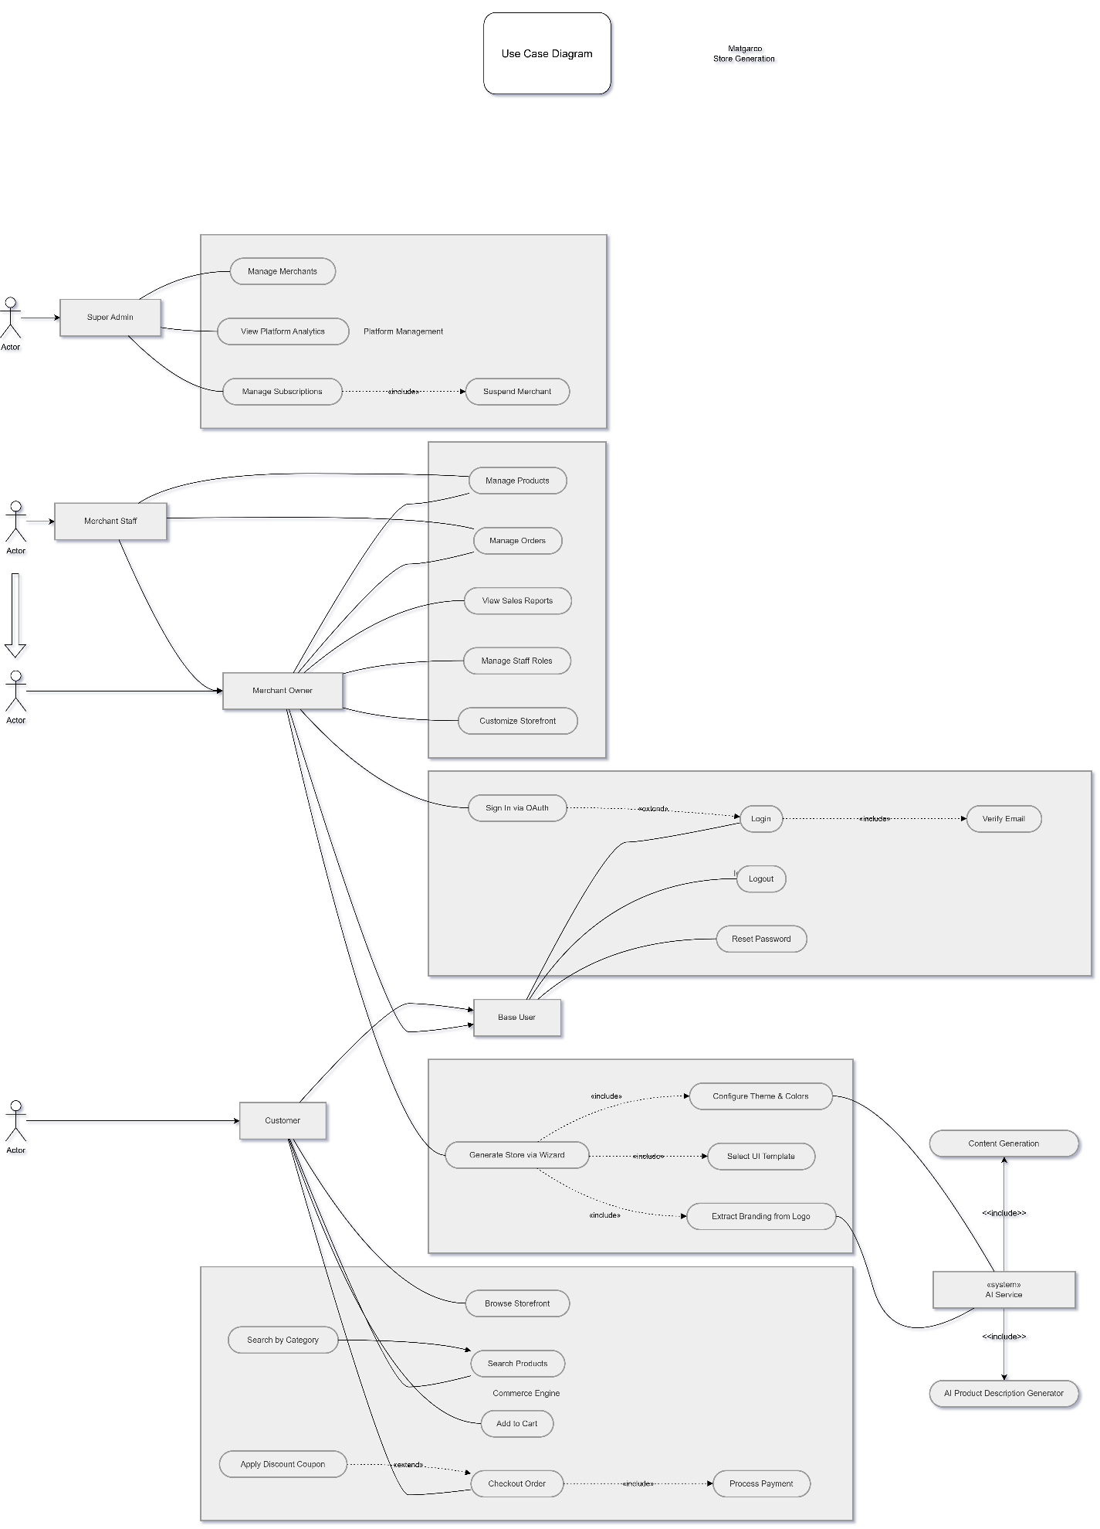

Activity Diagrams

4.2 Activity Diagram Modeling
4.2.1 Overview
Activity diagrams represent the behavioral essence of the Matgarco platform. Unlike static models, these diagrams illustrate the operational flow of control, data transformations, and decision-making logic. The following models analyze the two most critical workflows: AI-Driven Tenant Onboarding and the Transactional Commerce Loop.

4.2.2 Diagram 1: AI-Powered Store Generation Wizard
This diagram models the complex orchestration between the merchant, the core system, and the AI service to achieve a "Zero-Code" deployment.
I. Pre-Processing & Validation Layer
- Identity Input: The process initiates when the merchant provides a Brand Name and Logo.
- Systemic Guardrails: The system executes a dual-validation check:
  - Format Integrity: Restricting uploads to (PNG/JPG/SVG) to ensure compatibility with the AI Vision model. Failure triggers a Format Error.
  - Namespace Uniqueness: A real-time check of the Subdomain Registry. If the brand name is taken, the system returns a Subdomain Conflict Error, preventing routing collisions in the multi-tenant environment.
II. Resource Management (AI Credit System)
- Monetization Logic: Before invoking the AI API, the system validates the merchant's Subscription Credits. This ensures that generative resources are consumed only by authorized tenants. If credits are exhausted, the process terminates with an Insufficient Credits Error.

III. AI Orchestration & Graceful Degradation
- The AI Execution Loop: The system transmits the logo to the AI Service API for deep feature extraction (Colors, Typography, and Style).
- Heuristic Fallback: A critical decision node handles Extraction Failures. If the AI cannot resolve a palette, the system applies a Default Fallback Palette, ensuring system Availability and preventing onboarding abandonment.
IV. Provisioning & Global Deployment
- Tenant Provisioning: Upon user approval, the system executes the Infrastructure Layer tasks: Provisioning the Subdomain and assigning a unique merchantId.
- Deployment: The storefront is deployed as a PWA, embedded with a "Powered-By Matgarco" badge for brand traceability, culminating in the Launch Store event.

4.2.3 Diagram 2: Customer Purchase & Checkout Workflow
This model traces the B2C lifecycle, focusing on Data Isolation and External API Synchronicity.
I. Tenant-Isolated Discovery
- Scoped Session: The browsing experience is strictly merchantId Scoped. The system ensures that the frontend cart state and backend product queries are isolated within the specific tenant’s boundary (Tenant-Isolated Session).
II. Inventory & Pricing Logic
- Stock Integrity: A synchronous Backend Validation check is performed on all cart items. Any stock discrepancy triggers an Out of Stock Error.
- Promotion Engine: The system evaluates discount coupons against the merchantId rules. The flow branches into Coupon Validation, where valid codes trigger a Subtotal Re-calculation.
- Fiscal Resolution: The backend calculates the Final Total, incorporating Dynamic Taxes and Shipping fees in EGP.

III. Checkout & Fulfillment Orchestration
- Payment Branching: The workflow supports a hybrid payment model:
  - Synchronous Online Payment: An external handshake with the Payment Gateway (Paymob/Fawry). Failure results in a Payment Failure Error.
  - Asynchronous COD: Directly records the order under the merchantId.
- Logistics Integration: Upon successful payment or COD confirmation, the system triggers the Bosta Shipping API. This automates label generation and initiates the delivery lifecycle.
- Notification & Traceability: The process concludes with simultaneous Merchant/Customer Notifications and a confirmation display, reinforcing the platform's reliability.

4.2.4 Technical Modeling Conventions
To maintain academic rigor, the diagrams employ specific stylistic and logical notations:
- ClassDef Coloring: * Blue (#E3F2FD): External Human Actors (Merchant/Customer).
  - Orange (#FFF3E0): Core System Logic (Backend/System).
  - Purple (#F3E5F5): External/System Actors (AI Service/Gateway).
  - Red (#FFEBEE): Error & Exception Handling paths.
- Decision Diamonds: Represent real-time business rule evaluations (Credit validation, Stock availability, Subdomain checks).
- Termination Nodes: Differentiate between EndSuccess (Goal achieved) and EndErr (Graceful failure).

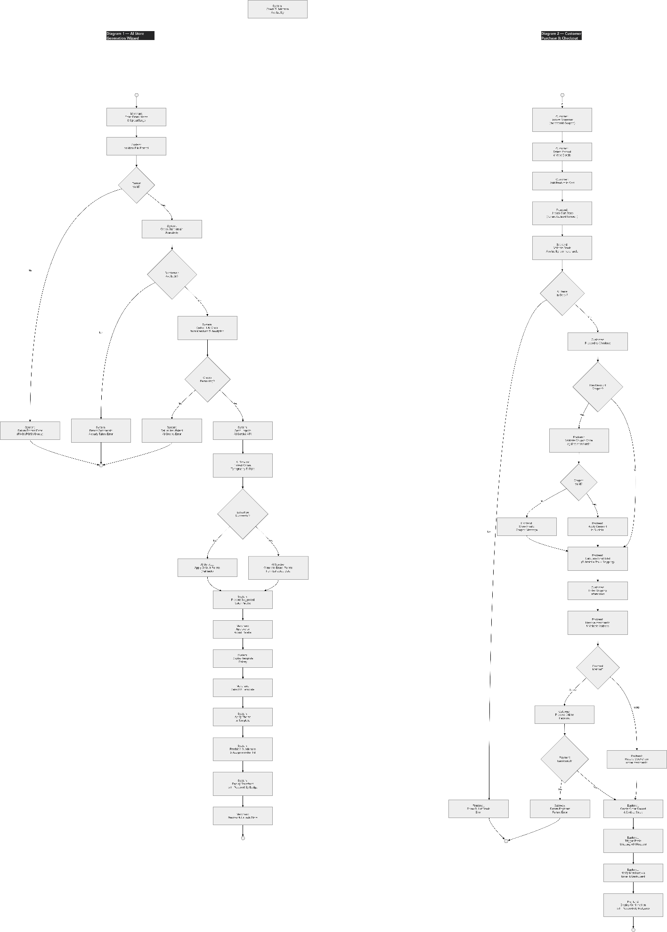

Sequence Diagrams

4.3.1 Overview
While Activity Diagrams model the logic flow, Sequence Diagrams represent the Behavioral Interaction between system objects over time. For the Matgarco platform, these diagrams are essential for visualizing the exchange of messages between the React.js Frontend, the Node.js/Express API, the Python FastAPI Service, and the MongoDB database. These models demonstrate how the system enforces Security, Multi-Tenant Isolation, and Cross-Service Orchestration.

4.3.2 Diagram 1: Secure Merchant Login & Identity Workflow
This diagram illustrates the authentication lifecycle and the establishment of the Tenant Context, which is the gateway to the SaaS environment.
I. Authentication & Verification Phases:
- Client-Side Filtering: The process begins on the React Dashboard, where initial field validation is performed to optimize server resources and enhance UX.
- Cryptographic Verification: Upon reaching the Node.js API, the system retrieves the user document. It utilizes the Bcrypt algorithm to perform a secure comparison between the provided password and the stored salted hash.
- The Identity Gate (Email Verification): Unlike standard systems, Matgarco enforces a strict isVerified check. If the merchant has not verified their email, the system returns a 403 Forbidden status, protecting the platform from unverified entities.

II. Session Management & Token Issuance:
- Dual-Token Strategy: Upon successful authentication, the API generates two distinct tokens:
  - Access Token (JWT): A short-lived token containing the userId, merchantId, and role. This token acts as the primary identity carrier for subsequent API requests.
  - Refresh Token: A long-lived token stored securely in the database to allow for seamless session renewal without re-authentication.
- Secure Persistence: The React Frontend stores the JWT in an HttpOnly Cookie (to prevent XSS attacks) and initializes the merchant’s profile state, completing the redirect to the dashboard.

4.3.3 Diagram 2: AI-Powered Product Creation (AI Copilot Flow)
This complex interaction model showcases the orchestration between the main API and the specialized AI Microservice, focusing on Quota Management and Data Isolation.
I. Phase 1: AI Content Generation & Quota Enforcement:
- Middleware Interception: Every request to the AI endpoint passes through the Tenant Middleware. The middleware decodes the JWT to extract the merchantId, ensuring that the identity is verified at the server level.
- Resource Governance (Quota Check): Before invoking the LLM, the API queries the aiUsage collection. It verifies the merchant’s remaining credits against their subscription tier (e.g., Professional). If the limit is reached, a 429 Too Many Requests error is triggered.
- Inter-Service Communication: If credits are available, the Node.js API acts as an Orchestrator, making an asynchronous POST request to the Python FastAPI Service. The AI service generates localized Arabic descriptions and SEO metadata using a specialized LLM.

II. Phase 2: Mandatory Tenant Context Injection & Storage:
- Security against IDOR: During the "Save Product" stage, the backend ignores any merchant ID provided by the frontend. Instead, it re-extracts the merchantId from the verified JWT.
- Mandatory Injection: The API injects the extracted merchantId directly into the product document before persistence. This ensures that the record is mathematically locked to the correct tenant, preventing data leakage between different stores.
- Atomic Persistence: The product is saved to MongoDB, returning a 201 Created status, confirming that the new asset is live and isolated within the merchant’s digital boundary.

4.3.4 Technical Significance of the Models
The sequence modeling highlights several architectural strengths of Matgarco:
- Separation of Concerns: Decoupling the AI logic (FastAPI) from the business logic (Node.js).
- Stateful Security: Using JWTs to maintain a stateless yet secure connection that carries the merchantId context throughout the request lifecycle.
- Resilience: Handling edge cases like Password Mismatches, Verification Gates, and Credit Exhaustion through explicit alternative paths.

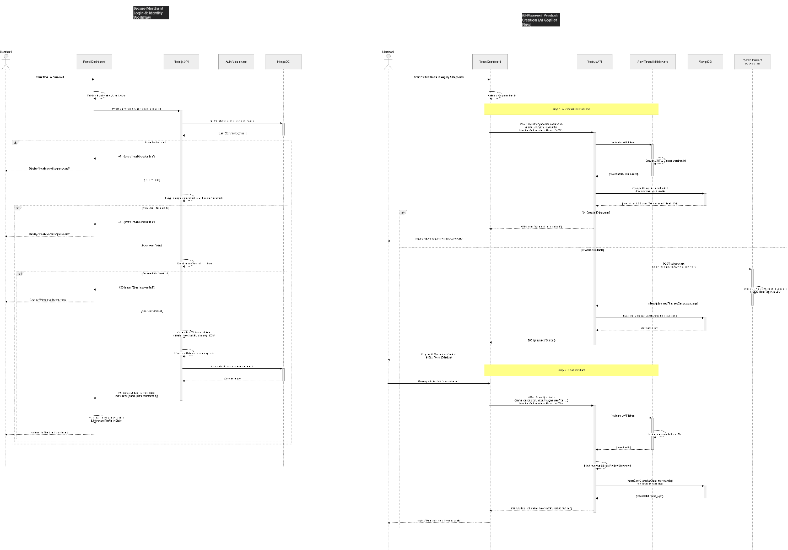

Class Diagram

4.4.1 Architectural Vision
The Class Diagram for Matgarco represents a formal blueprint of the platform’s structural integrity. It is engineered using a 4-Layer Decoupled Design, adhering to the Dependency Inversion Principle. The architecture is designed to ensure strict Tenant Isolation, where business logic is separated from data persistence and external integrations.
4.4.2 Deep Dive into the Layered Infrastructure
Layer 0: Infrastructure & Security (The Foundation)
This layer governs the multi-tenant nature of the platform:
- TenantContext (Singleton Pattern): A critical class that maintains the "Merchant Identity" during the request lifecycle. It encapsulates the merchantId and role, ensuring that identity context is persistent and accessible without data leakage.
- TenantMiddleware: Acts as an Interception Filter. It decodes incoming JWTs and populates the TenantContext, serving as the primary security gate for all tenant-specific operations.
- BaseRepository<T> (Abstract Abstraction): A generic base class that centralizes CRUD logic. Its most innovative feature is the scopeByMerchant() method, which automatically injects a tenant-filter into every database query, ensuring that isolation is enforced at the repository level.
Layer 1: Domain Entities (The Data Model)
Represents the core business objects and their relationships:
- Identity Hierarchy: Uses Inheritance where Merchant and Staff extend the User class, sharing common attributes (Email, Password) while adding specialized metadata.
- Commerce Entities: Includes Product, Order, Category, and Customer. Note the Composition relationship between Order and OrderItem; an OrderItem cannot exist independently of its parent Order.
- SaaS Logic: Subscription and AIUsage classes track merchant limits and credit consumption, directly interacting with the Service Layer to lock or unlock features dynamically.
Layer 2 & 3: Repository and Service Layers (The Engine)
- Repository Layer: Specialized repositories (e.g., ProductRepository) extend the BaseRepository to handle complex, domain-specific queries like stock updates or revenue statistics.
- Service Layer (Business Logic): Classes like ProductService and OrderService act as Orchestrators. They depend on repositories for data and other services for cross-cutting concerns (e.g., OrderService depends on NotificationService to alert the merchant of new sales).
Layer 4: Controller Layer (The API Contract)
Controllers (e.g., AuthController, MerchantController) handle HTTP requests and delegate execution to the Service Layer. They are protected by the TenantMiddleware, ensuring that only authorized requests reach the business logic.

4.4.3 UML Relationship Specifications
The model utilizes formal UML notations to describe system connectivity:
- Inheritance (<|--): Used in the Identity layer to reuse code and define a clear role hierarchy.
- Composition (*--): Represents a "Strong Ownership" between Order and OrderItem, ensuring transactional consistency.
- Aggregation (o--): Used for the relationship between Merchant and Staff, as staff members are logically grouped under a merchant but possess their own independent user identity.
- Association (-->): Illustrates the flow of Dependency Injection (DI), where services depend on repositories and infrastructure clients (e.g., AIService depends on FastAPIClient).

4.4.4 Design Patterns & Systemic Guardrails
- Singleton Pattern: Applied to TenantContext to ensure a single source of truth for the current requester's identity.
- Generic Repository Pattern: Reduces code duplication and centralizes Tenant Scoping logic.
- External Service Decoupling: The FastAPIClient encapsulates the complexity of communicating with the Python AI microservice, protecting the core Node.js API from changes in external API specifications.
- Enumerations: Strict types like OrderStatus and UserRole are used to prevent invalid states within the system workflow.

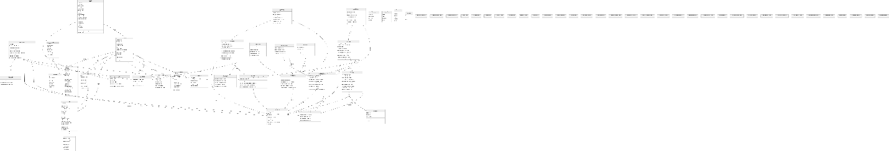

Entity Relationship Diagram (ERD)

4.5.1 Introduction
The Entity Relationship Diagram (ERD) constitutes the logical foundation of the Matgarco data architecture. While the system utilizes a NoSQL (MongoDB) backend, the schema is designed with strict relational integrity to support a High-Performance Multi-Tenant SaaS environment. This model focuses on three critical pillars: Data Isolation, Bilingual Content Persistence, and Transactional Auditability.
4.5.2 Architectural Schema Principles
Principle | Academic Justification
Strict Multi-Tenancy | Every operational entity is anchored by a merchantId Foreign Key (FK). This ensures that the Tenant Isolation Middleware can filter data at the query level, preventing any unauthorized cross-tenant data access.
Localized Content Mirroring | To address the linguistic requirements of the MENA market, the schema employs "Bilingual Mirroring" (e.g., name vs nameAr). This allows the system to serve RTL and LTR storefronts dynamically without additional translation overhead.
Stateful Snapshots | In the OrderItems entity, the schema records snapshots of product data (Price, Name) at the time of purchase. This prevents historical data corruption if a merchant later modifies the original product document.

4.5.3 Entity Domain Categorization
I. Identity and Access Management (IAM) Domain
- Users: The central repository for authentication. It employs an Enumerated Role System (Admin, Merchant, Staff) and maintains security flags such as isVerified and isActive.
- Merchants: The core "Tenant Root". It maps the unique subdomain to an ownerId. It stores essential metadata for business identity, such as businessType and contactPhone.
II. Product & Catalog Management Domain
- Categories: Organized as a hierarchical structure. The slug field is indexed as a Unique Key (UK) for SEO-friendly routing.
- Products: A complex entity managing the commerce inventory. It supports JSON-based attributes for variant management (Size/Color) and includes specific SEO Metadata fields (seoTitle, seoTitleAr) to enhance organic discoverability.
III. Transactional & Fulfillment Domain
- Orders: The financial core of the system. It calculates a multi-layered pricing model: Subtotal + 14% VAT + Shipping Cost - Discounts. It also tracks the Platform Commission, facilitating the SaaS monetization logic.
- OrderItems: A child entity of Orders. It handles line-level granularity, ensuring each item is mapped back to its source productId for inventory synchronization.
- Customers: A merchant-specific CRM entity. It tracks the firstPurchase date and stores shipping demographics (City, Governorate) to drive marketing analytics.

IV. SaaS Configuration & Intelligence Domain
- Subscriptions: Manages the service tier (Lite, Pro, Prime). It enforces strict architectural limits such as maxProducts and maxStaffAccounts.
- AIUsage: Orchestrates the consumption of generative resources. Notably, it implements a "Rollover Logic" exclusive to the Prime tier, allowing unused credits to accumulate.
- StoreConfig: Separates the visual presentation from business logic. It stores branding assets (Hex colors, Logo URLs) and template identifiers to render the PWA storefront dynamically.
- Analytics: A high-velocity entity that records event-driven data (Visitor ID, Device Type, Source) to provide merchants with real-time business intelligence.

4.5.4 Relational Cardinality and Integrity Constraints
The system enforces several critical cardinalities to maintain data consistency:
- Identity Linkage (1:1 / 1:N): One User can own one Merchant instance (as a root owner), while one Merchant can employ multiple Staff accounts (Users) through a 1:N relationship.
- Infrastructure Mapping (1:1): A Merchant has a strict one-to-one relationship with their Subscription, StoreConfig, and AIUsage documents, ensuring a clean SaaS profile.
- Commerce Hierarchy (1:N):
  - A Category contains many Products.
  - A Merchant owns multiple Products, Orders, and Customers.
- Order Decomposition (1:N): An Order consists of multiple OrderItems, where each item is a mandatory reference to a specific Product.
4.5.5 Technical Significance: Query Scoping
By centralizing the merchantId as a mandatory Foreign Key in nearly every collection, the ERD enables the system to implement Implicit Query Scoping. This technical choice ensures that every database transaction is mathematically bound to its specific tenant, upholding the highest standards of Cloud Data Security.

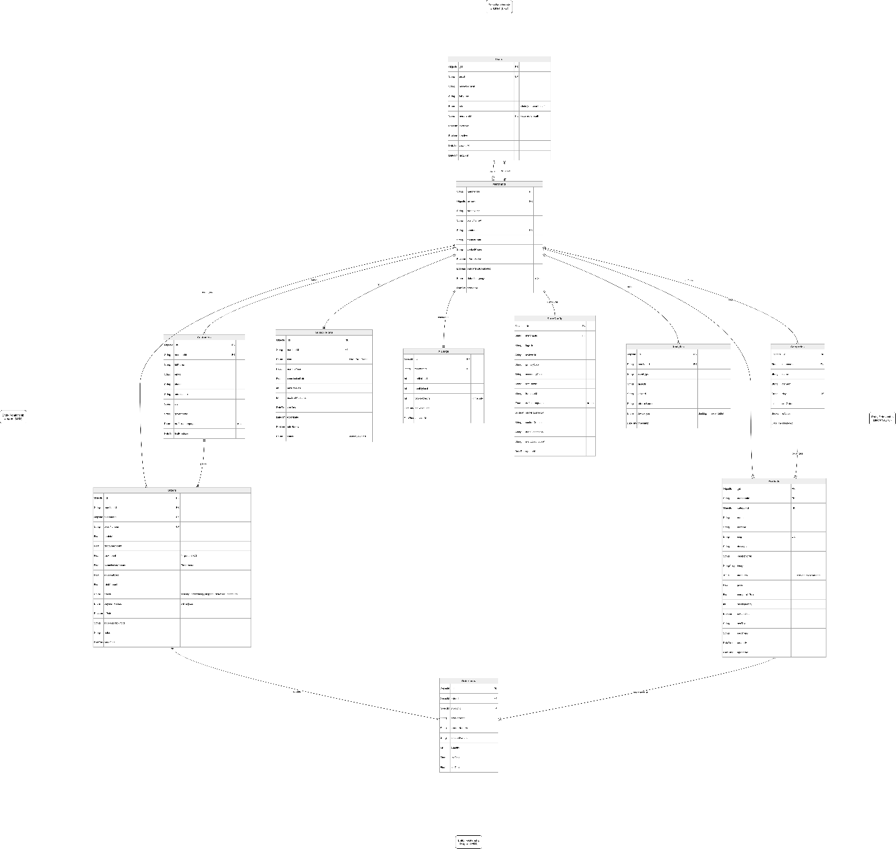

Chapter five

System Design

Chapter 5: System Design

System architecture

Website map

UI/UX

Database schema

Chapter six

System Implementation & testing

Chapter 6: System Implementation & Testing

System Tools

Core features implemented

User Interface organized and documented

Source code organized and documented

Database connected

Test plan and test cases prepared

Testing the core features with sample data

Testing report

Chapter seven

Conclusions and Future Work

Chapter 7: Conclusions and Future Work

Conclusion

Future Work

References

Appendices

